Jenkins Fundamentals

TYPES OF TESTING — SLOWER
- functional tests — validate the normal software behaviors against
the expectations and requirements
- non-regression tests — validates that the system still produces
the same result
- acceptance tests — tests the full product from the perspective of
the end-user use cases and feelings. Probably includes manual testing

MANUAL TESTING
- Is appropriate when test result is subjective, such as user experience testing
- May also be used when the cost of automation is excessive for some reason
- Should be performed rarely, and only on software that has passed all automated tests

TESTING PYRAMID
- Tests at the bottom of the pyramid run quickly and inexpensively and should be run very frequently
- Tests at the top of the pyramid take more time to run and are expensive; they should be run less frequently and only on software that has passed the tests lower on the pyramid.
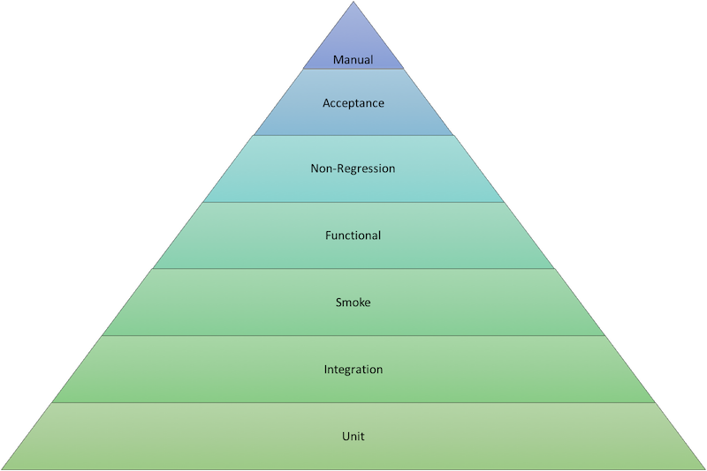

TYPES OF TESTING — SLOWER
- functional tests — validate the normal software behaviors against
the expectations and requirements
- non-regression tests — validates that the system still produces
the same result
- acceptance tests — tests the full product from the perspective of
the end-user use cases and feelings. Probably includes manual testing

MANUAL TESTING
- Is appropriate when test result is subjective, such as user experience testing
- May also be used when the cost of automation is excessive for some reason
- Should be performed rarely, and only on software that has passed all automated tests

TESTING PYRAMID
- Tests at the bottom of the pyramid run quickly and inexpensively and should be run very frequently
- Tests at the top of the pyramid take more time to run and are expensive; they should be run less frequently and only on software that has passed the tests lower on the pyramid.

TYPES OF TESTING — SLOWER
- functional tests — validate the normal software behaviors against
the expectations and requirements
- non-regression tests — validates that the system still produces
the same result
- acceptance tests — tests the full product from the perspective of
the end-user use cases and feelings. Probably includes manual testing

MANUAL TESTING
- Is appropriate when test result is subjective, such as user experience testing
- May also be used when the cost of automation is excessive for some reason
- Should be performed rarely, and only on software that has passed all automated tests

TESTING PYRAMID
- Tests at the bottom of the pyramid run quickly and inexpensively and should be run very frequently
- Tests at the top of the pyramid take more time to run and are expensive; they should be run less frequently and only on software that has passed the tests lower on the pyramid.

TYPES OF TESTING — SLOWER
- functional tests — validate the normal software behaviors against
the expectations and requirements
- non-regression tests — validates that the system still produces
the same result
- acceptance tests — tests the full product from the perspective of
the end-user use cases and feelings. Probably includes manual testing

MANUAL TESTING
- Is appropriate when test result is subjective, such as user experience testing
- May also be used when the cost of automation is excessive for some reason
- Should be performed rarely, and only on software that has passed all automated tests

TESTING PYRAMID
- Tests at the bottom of the pyramid run quickly and inexpensively and should be run very frequently
- Tests at the top of the pyramid take more time to run and are expensive; they should be run less frequently and only on software that has passed the tests lower on the pyramid.

TYPES OF TESTING — SLOWER
- functional tests — validate the normal software behaviors against
the expectations and requirements
- non-regression tests — validates that the system still produces
the same result
- acceptance tests — tests the full product from the perspective of
the end-user use cases and feelings. Probably includes manual testing

MANUAL TESTING
- Is appropriate when test result is subjective, such as user experience testing
- May also be used when the cost of automation is excessive for some reason
- Should be performed rarely, and only on software that has passed all automated tests

TESTING PYRAMID
- Tests at the bottom of the pyramid run quickly and inexpensively and should be run very frequently
- Tests at the top of the pyramid take more time to run and are expensive; they should be run less frequently and only on software that has passed the tests lower on the pyramid.

TYPES OF TESTING — SLOWER
- functional tests — validate the normal software behaviors against
the expectations and requirements
- non-regression tests — validates that the system still produces
the same result
- acceptance tests — tests the full product from the perspective of
the end-user use cases and feelings. Probably includes manual testing

MANUAL TESTING
- Is appropriate when test result is subjective, such as user experience testing
- May also be used when the cost of automation is excessive for some reason
- Should be performed rarely, and only on software that has passed all automated tests

TESTING PYRAMID
- Tests at the bottom of the pyramid run quickly and inexpensively and should be run very frequently
- Tests at the top of the pyramid take more time to run and are expensive; they should be run less frequently and only on software that has passed the tests lower on the pyramid.

TYPES OF TESTING — SLOWER
- functional tests — validate the normal software behaviors against
the expectations and requirements
- non-regression tests — validates that the system still produces
the same result
- acceptance tests — tests the full product from the perspective of
the end-user use cases and feelings. Probably includes manual testing

MANUAL TESTING
- Is appropriate when test result is subjective, such as user experience testing
- May also be used when the cost of automation is excessive for some reason
- Should be performed rarely, and only on software that has passed all automated tests

TESTING PYRAMID
- Tests at the bottom of the pyramid run quickly and inexpensively and should be run very frequently
- Tests at the top of the pyramid take more time to run and are expensive; they should be run less frequently and only on software that has passed the tests lower on the pyramid.

TYPES OF TESTING — SLOWER
- functional tests — validate the normal software behaviors against
the expectations and requirements
- non-regression tests — validates that the system still produces
the same result
- acceptance tests — tests the full product from the perspective of
the end-user use cases and feelings. Probably includes manual testing

MANUAL TESTING
- Is appropriate when test result is subjective, such as user experience testing
- May also be used when the cost of automation is excessive for some reason
- Should be performed rarely, and only on software that has passed all automated tests

TESTING PYRAMID
- Tests at the bottom of the pyramid run quickly and inexpensively and should be run very frequently
- Tests at the top of the pyramid take more time to run and are expensive; they should be run less frequently and only on software that has passed the tests lower on the pyramid.

TYPES OF TESTING — SLOWER
- functional tests — validate the normal software behaviors against
the expectations and requirements
- non-regression tests — validates that the system still produces
the same result
- acceptance tests — tests the full product from the perspective of
the end-user use cases and feelings. Probably includes manual testing

MANUAL TESTING
- Is appropriate when test result is subjective, such as user experience testing
- May also be used when the cost of automation is excessive for some reason
- Should be performed rarely, and only on software that has passed all automated tests

TESTING PYRAMID
- Tests at the bottom of the pyramid run quickly and inexpensively and should be run very frequently
- Tests at the top of the pyramid take more time to run and are expensive; they should be run less frequently and only on software that has passed the tests lower on the pyramid.

TYPES OF TESTING — SLOWER
- functional tests — validate the normal software behaviors against
the expectations and requirements
- non-regression tests — validates that the system still produces
the same result
- acceptance tests — tests the full product from the perspective of
the end-user use cases and feelings. Probably includes manual testing

MANUAL TESTING
- Is appropriate when test result is subjective, such as user experience testing
- May also be used when the cost of automation is excessive for some reason
- Should be performed rarely, and only on software that has passed all automated tests

TESTING PYRAMID
- Tests at the bottom of the pyramid run quickly and inexpensively and should be run very frequently
- Tests at the top of the pyramid take more time to run and are expensive; they should be run less frequently and only on software that has passed the tests lower on the pyramid.

TYPES OF TESTING — SLOWER
- functional tests — validate the normal software behaviors against
the expectations and requirements
- non-regression tests — validates that the system still produces
the same result
- acceptance tests — tests the full product from the perspective of
the end-user use cases and feelings. Probably includes manual testing

MANUAL TESTING
- Is appropriate when test result is subjective, such as user experience testing
- May also be used when the cost of automation is excessive for some reason
- Should be performed rarely, and only on software that has passed all automated tests

TESTING PYRAMID
- Tests at the bottom of the pyramid run quickly and inexpensively and should be run very frequently
- Tests at the top of the pyramid take more time to run and are expensive; they should be run less frequently and only on software that has passed the tests lower on the pyramid.

TYPES OF TESTING — SLOWER
- functional tests — validate the normal software behaviors against
the expectations and requirements
- non-regression tests — validates that the system still produces
the same result
- acceptance tests — tests the full product from the perspective of
the end-user use cases and feelings. Probably includes manual testing

MANUAL TESTING
- Is appropriate when test result is subjective, such as user experience testing
- May also be used when the cost of automation is excessive for some reason
- Should be performed rarely, and only on software that has passed all automated tests

TESTING PYRAMID
- Tests at the bottom of the pyramid run quickly and inexpensively and should be run very frequently
- Tests at the top of the pyramid take more time to run and are expensive; they should be run less frequently and only on software that has passed the tests lower on the pyramid.

– cloudBees

SCM REPOSITORY
- Code is stored in a repository (or "repo")
  - Creating separate repositories (one per product, for example) allows more granular control
- You control who can access each repo and define whether they have read, write, or admin privileges
- You can also enforce "good practices", such as requiring that each code modification is reviewed and approved by someone other than its author
- The current official version of the code is master
- The Jenkinsfile that specifies how Jenkins runs the build cycle is a text file that is stored in the repo along with the code

SCM WORKFLOW — MODIFYING THE CODE
- To modify the code:
  - Clone (copy) the repo to your local computer
  - Create a branch for the change you want to make
  - Modify your local codebase and test your changes locally
  - Create a commit that contains the modified codebase
  - Push your commit to the remote, official repository

SCM WORKFLOW — UPDATING THE REPOSITORY
- After you push your commit to the remote repository, create a Pull Request (PR) to request that it be merged into the master branch.
- Jenkins then builds and tests the contents of your changes against what is currently in master and flags any issues
- Colleagues review, comment, and approve your PR
- The contents of the PR can be modified on the remote site or you can push additional commits from your local clone
- When ready, the PR can be merged to master

SCM TERMINOLOGY: BASICS
- Each set of changed lines on a single file is a diff
- A set of diffs that have been explicitly validated forms a commit

- A commit is actually a new version of the codebase
- A commit can exist only locally or only remotely
- The latest commit on the history is the HEAD
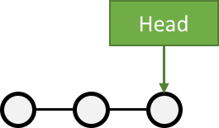

SCM TERMINOLOGY: BRANCHES
- A branch, in SCM terminology, is a pointer to a single commit
  - HEAD is the "latest" branch, also known as the masterbranch
  - To integrate a branch, you must merge it:
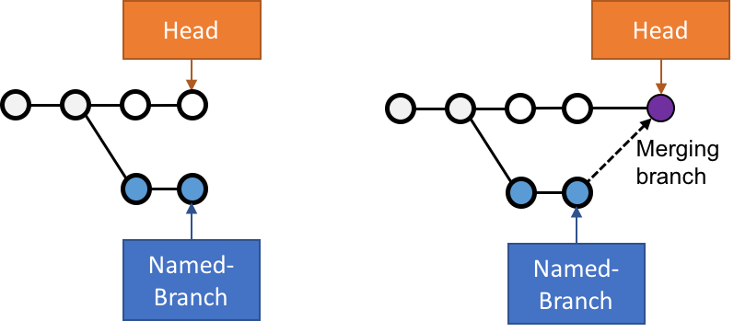

SCM TERMINOLOGY: PULL REQUEST
- A Pull Request is a way of proposing a change to others without writing to their repository
  - A branch is pushed to the central server
  - It "asks" to be merged to the central repository
  - Opportunity is given to review the changes before merging
  - Pull request ends by being closed or merged to destination branch
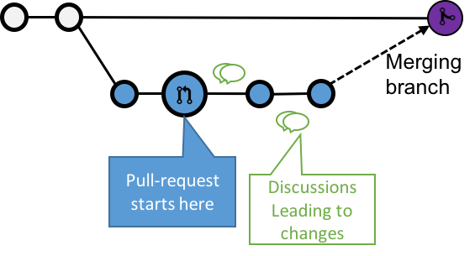

TYPES OF TESTING — FASTER
- unit tests — test a small piece of code (a function or method or command);
run blazingly fast, and are often written by the person who wrote the code
- integration tests — validate integration between multiple sub-systems,
including external sub-systems like a database
- smoke tests — validates basic functions of the system;
also known as sanity checking

- functional tests — validate the normal software behaviors against
the expectations and requirements
- non-regression tests — validates that the system still produces
the same result
- acceptance tests — tests the full product from the perspective of
the end-user use cases and feelings. Probably includes manual testing

TESTING PYRAMID
- Tests at the bottom of the pyramid run quickly and inexpensively and should be run very frequently
- Tests at the top of the pyramid take more time to run and are expensive; they should be run less frequently and only on software that has passed the tests lower on the pyramid.

